Module Name: Login Module
Test Case ID: 183
Webpage URL: https://opensource-demo.orangehrmlive.com/

● Scenario ID: 9a
Scenario: Black-Box Testing - Valid login
Test Steps:
- Open OrangeHRM
- Enter valid username
- Enter valid password
- Click Login
Screenshots:-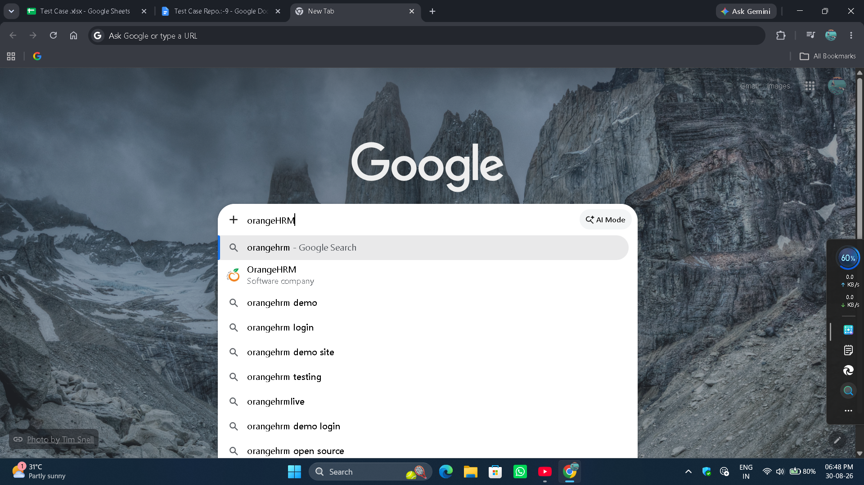

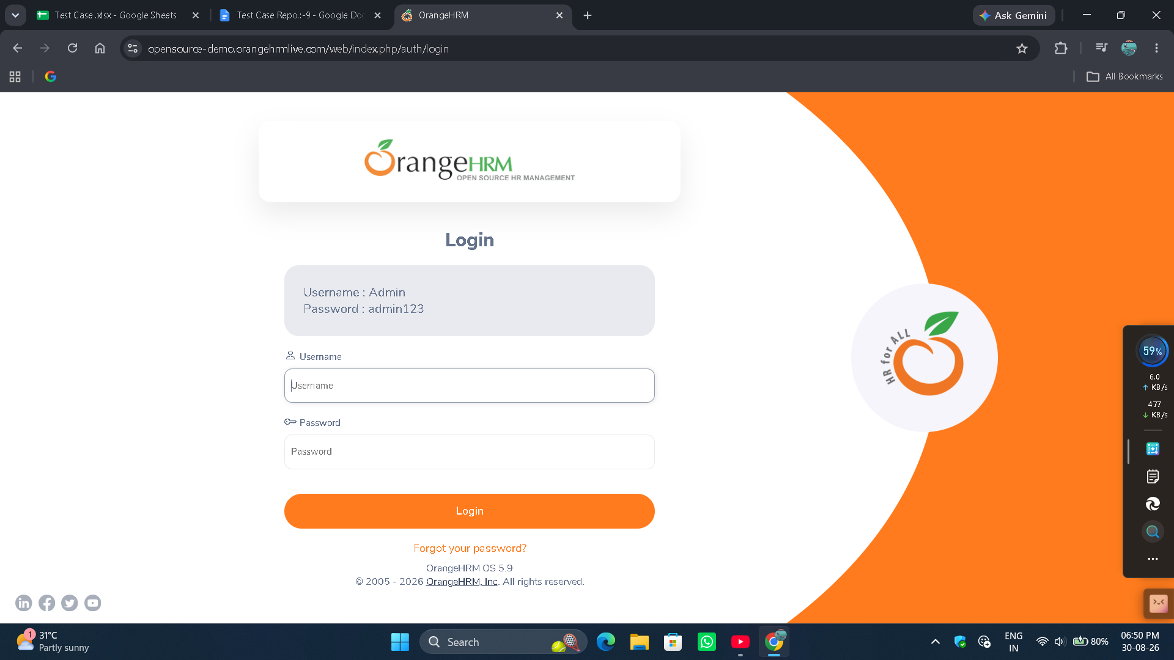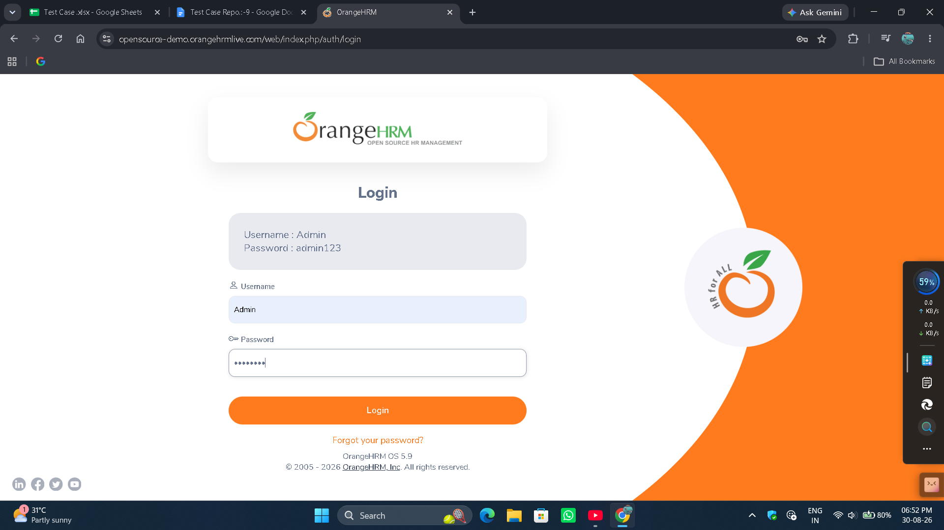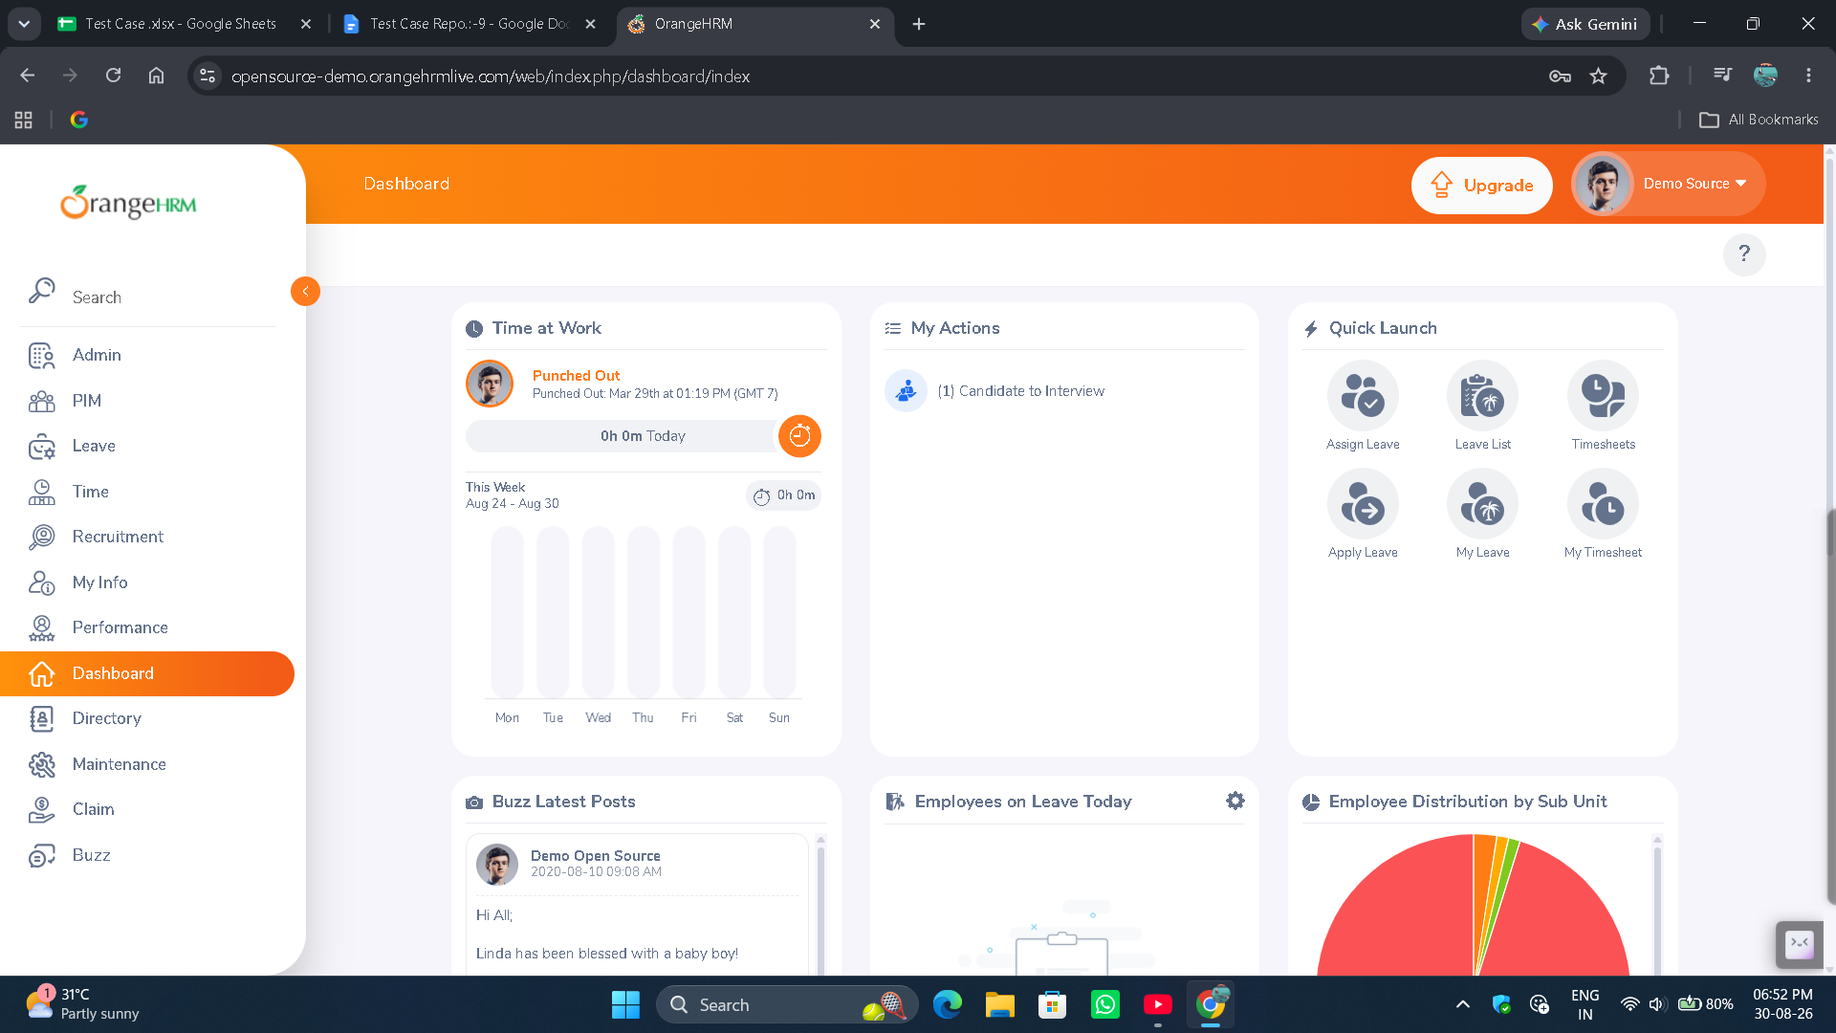
● Scenario ID: 9b
Scenario: Black-Box Testing - Invalid login
Test Steps:
- Open OrangeHRM
- Enter valid username
- Enter Invalid password
- Click Login
Screenshots:-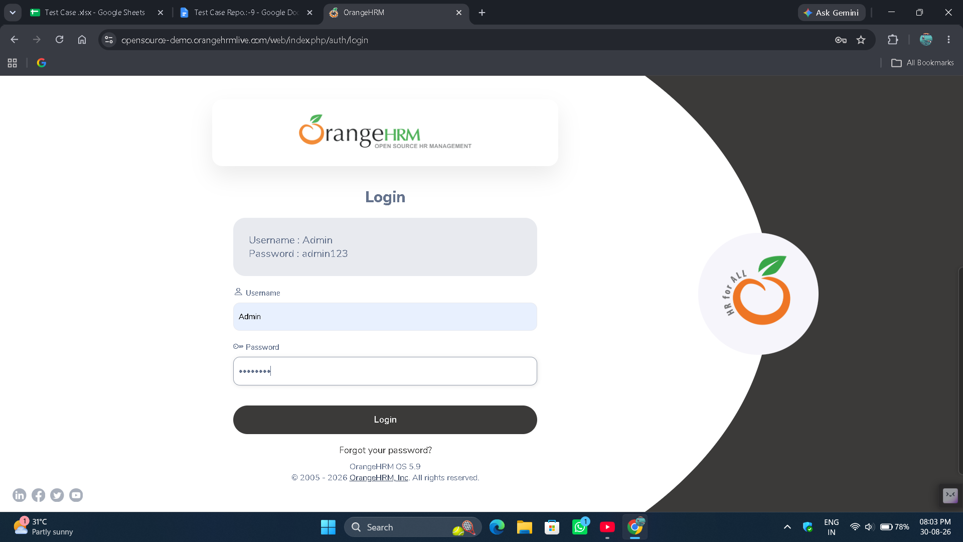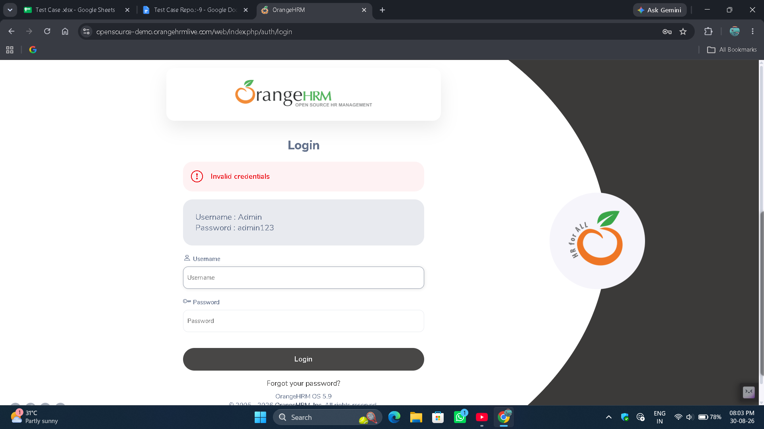

● Scenario ID: 9c
Scenario: White-Box Testing - Login Validation Path
Test Steps:
- Keep one or more login fields empty
- Click Login
- Observe validation behavior
Screenshots:-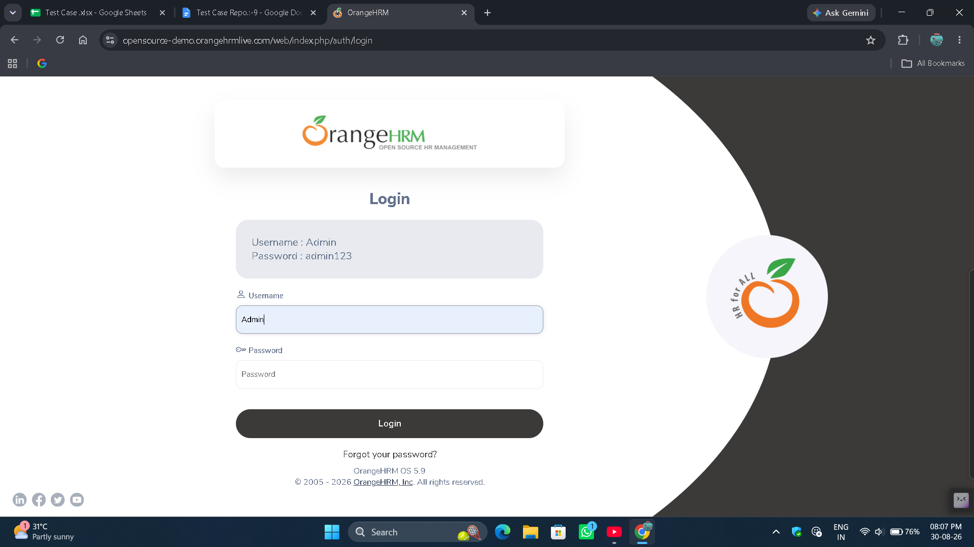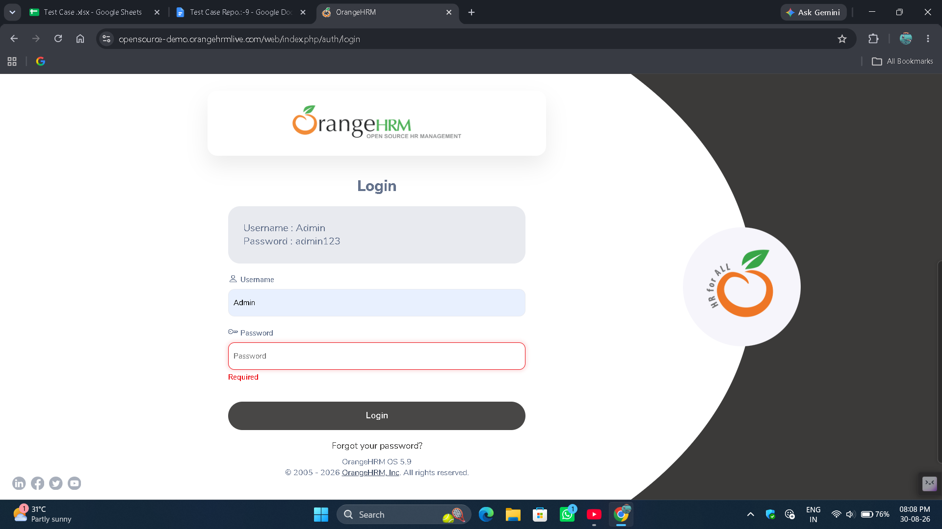
● Scenario ID: 9d
Scenario: Integration Testing - Login to Dashboard
Test Steps:
- Perform successful login
- Verify authentication result
- Verify dashboard loading
- Check navigation access

Screenshots:-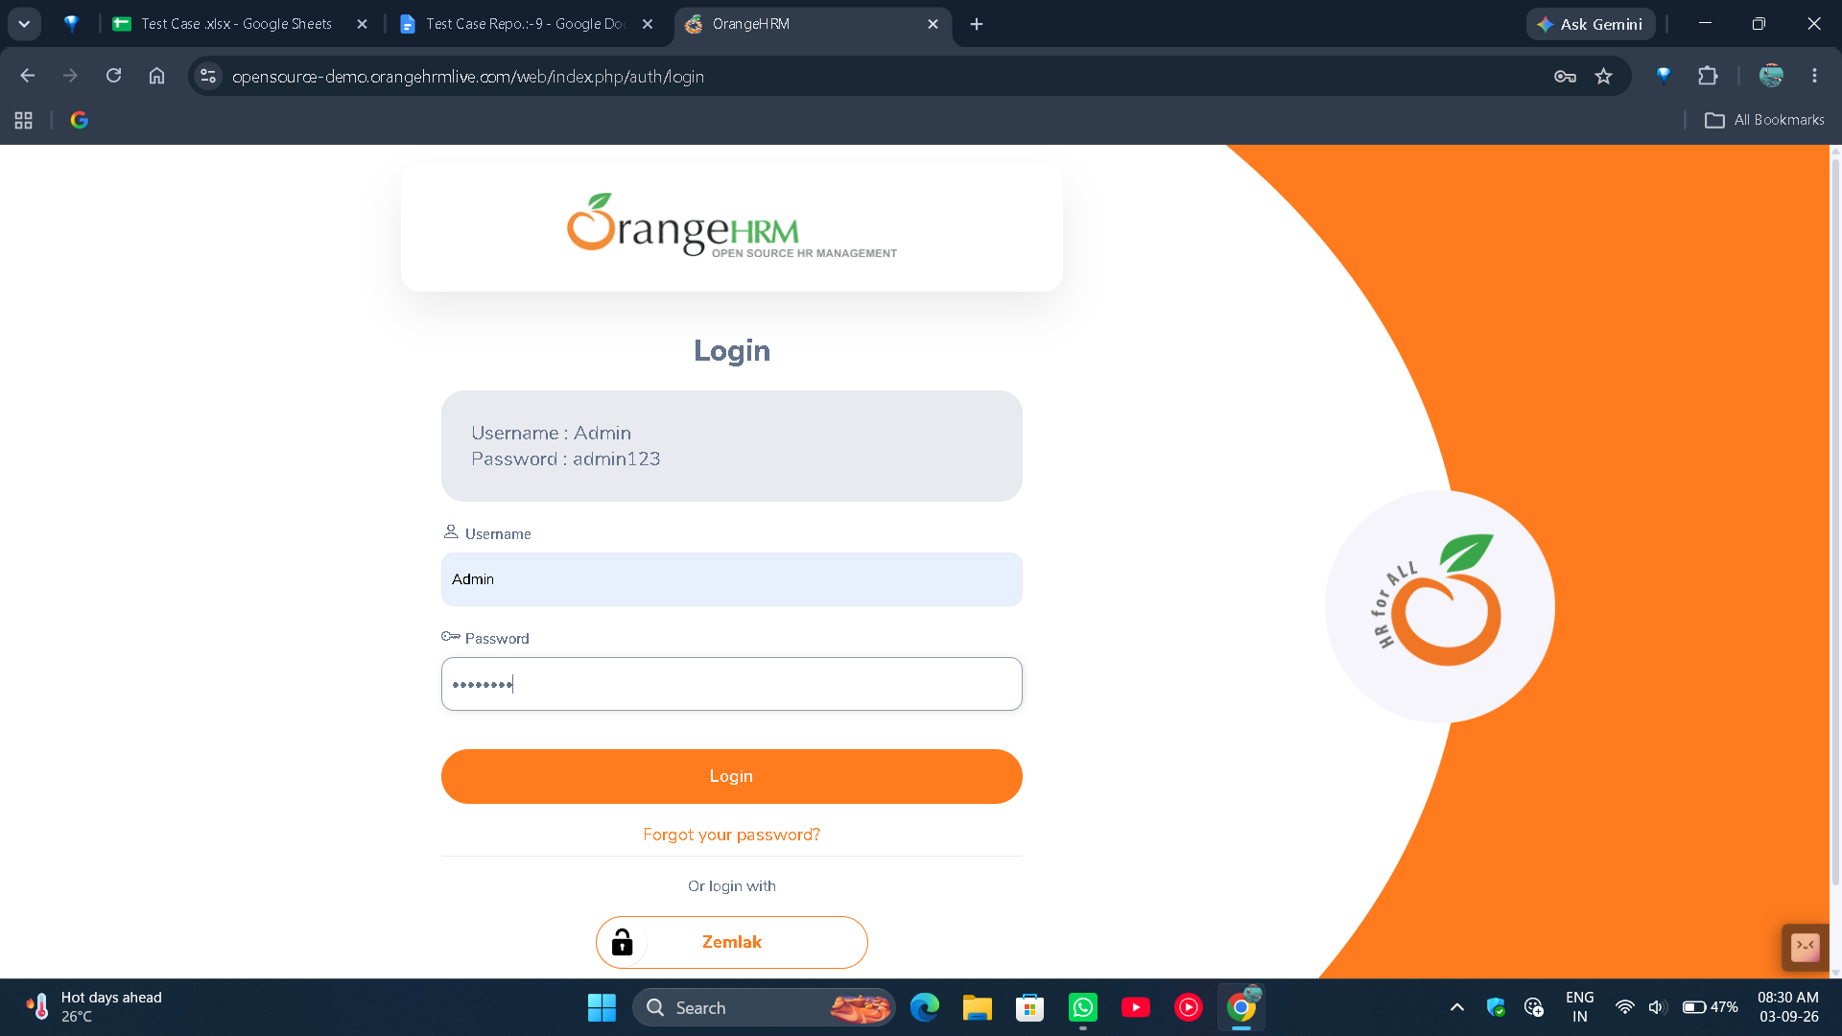
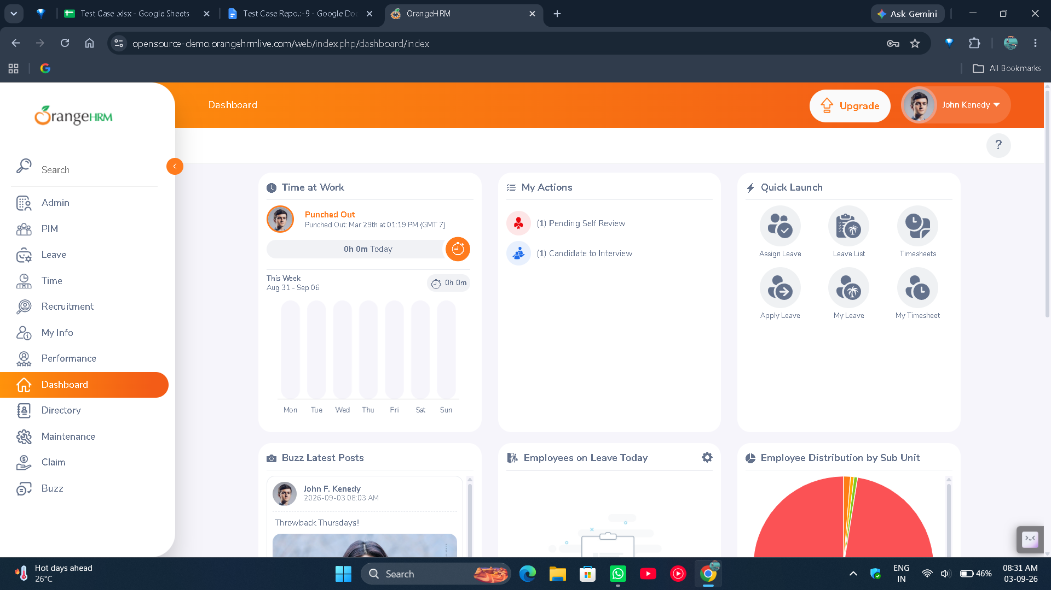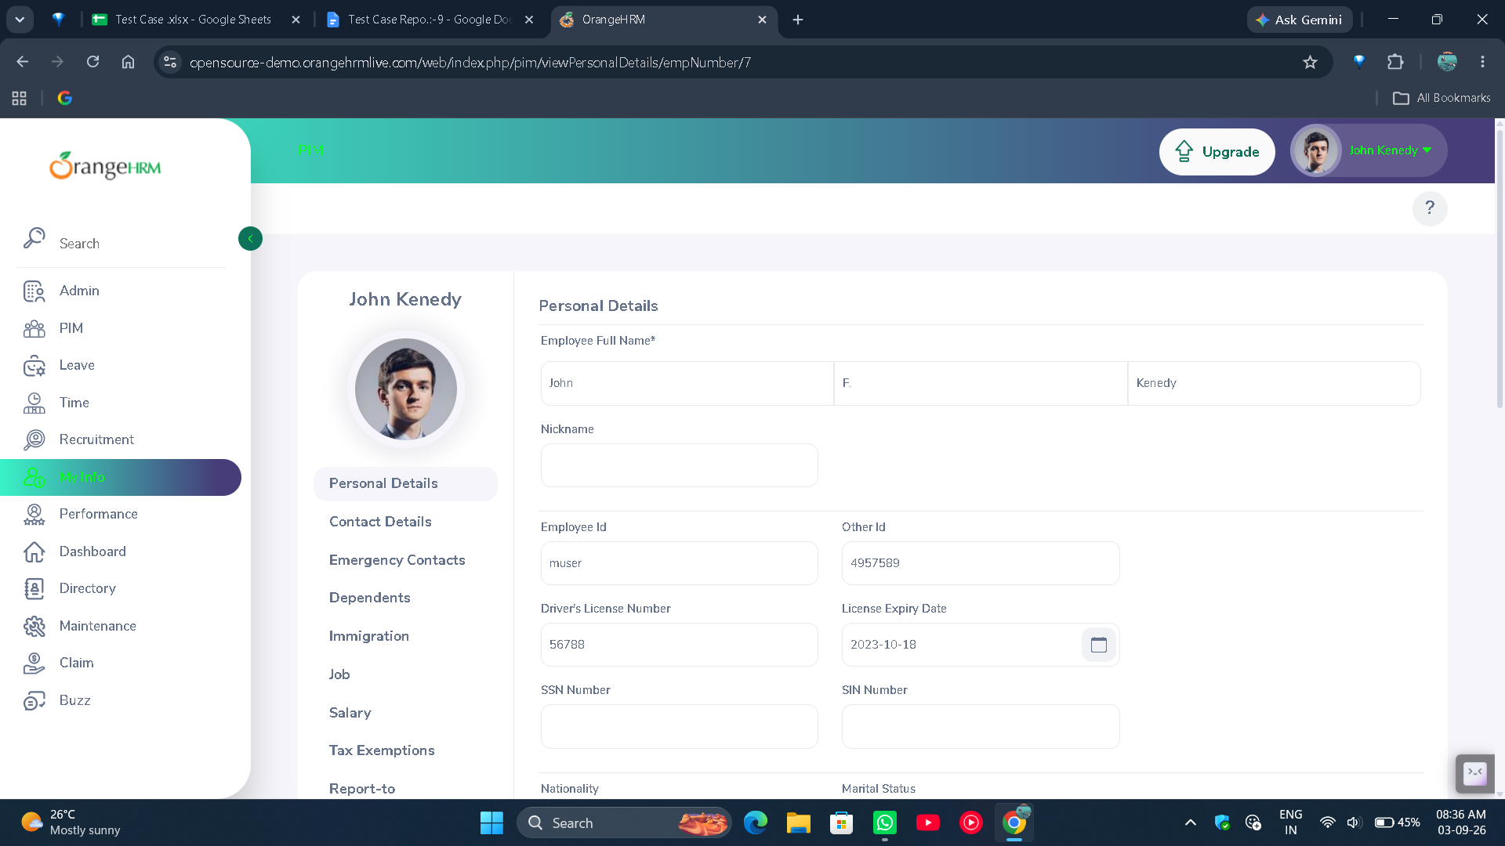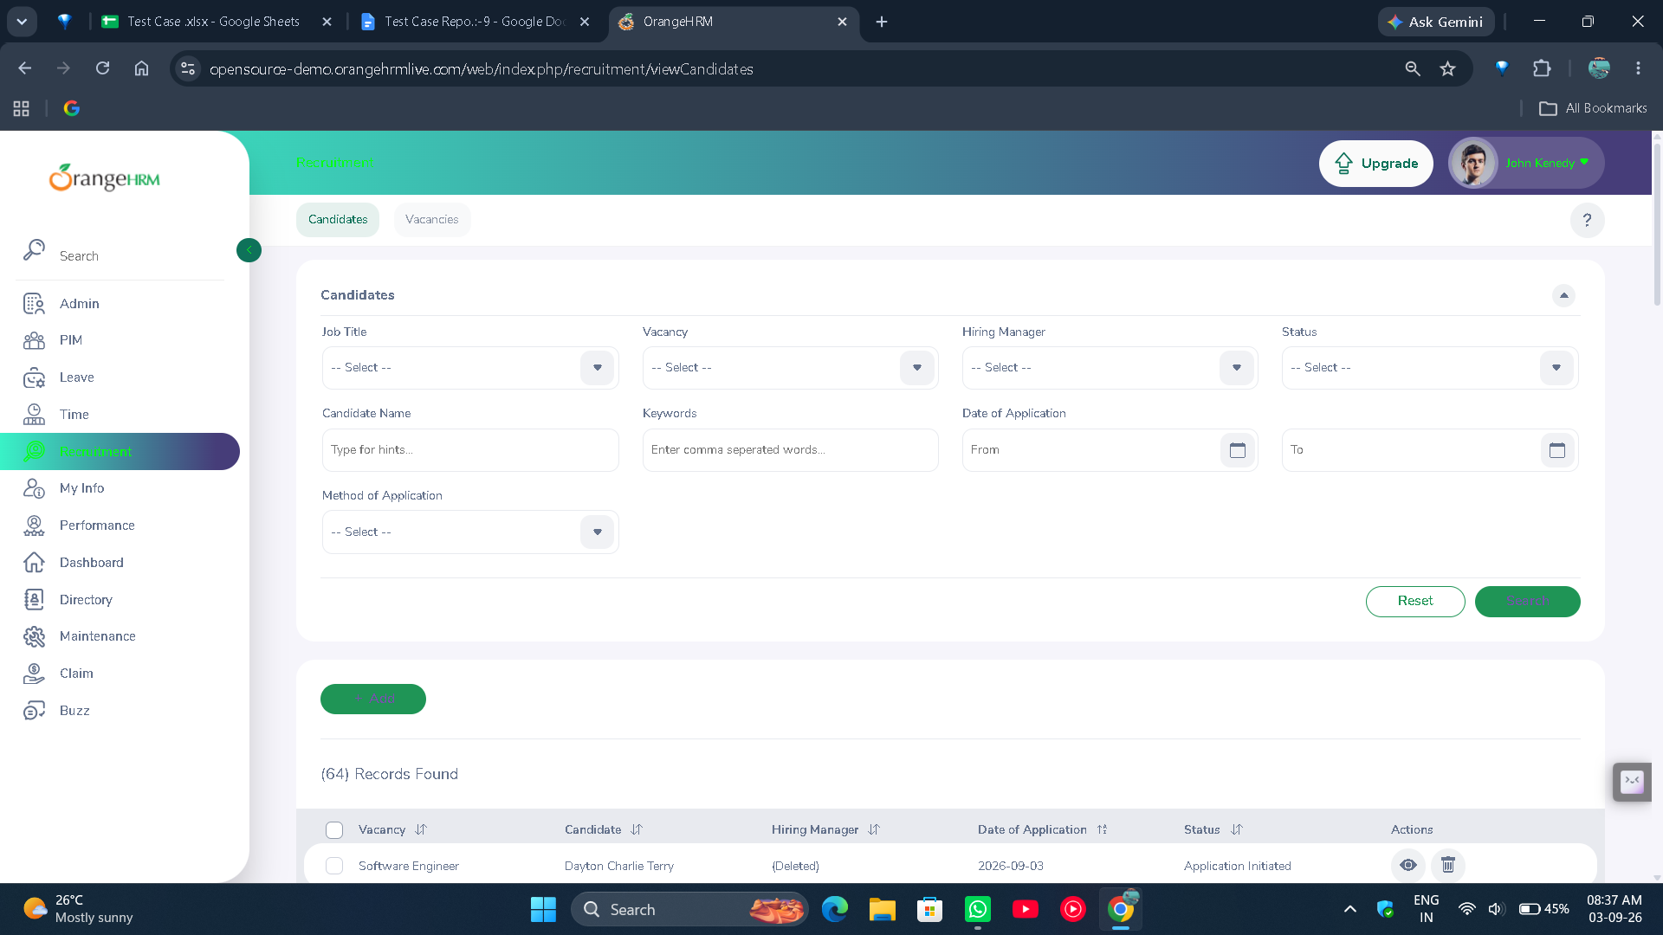
● Scenario ID: 9e
Scenario: System Testing - Complete user workflow
Test Steps:
- Open application
- Login successfully
- Access dashboard
- Navigate to available modules
- Logout

Screenshots:-